SINGING CIRCLES

A collection of Early Years songs
to promote language acquisition and develop social play

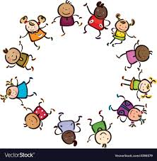

Singing activities for
‘Scrunchies’ (stretchy fabric rings)
Lycra sheets and parachutes

INTRODUCTION
This book began as a ‘Music and Drama Expo’ seminar in 2019, offering songs to promote language acquisition and encourage social play, focusing on the particular characteristics of ‘Scrunchies’ (stretchy fabric rings), Lycra sheets and parachutes. However, realising that there was a demand for more of this kind of material, the original collection has been expanded to become a book … songs for story-building and word-play … songs for actions and dance ….songs to entertain and amuse!
‘Singing circles’ - learning through play
- Circles provide the ideal democratic play space with no obvious leader position
- Participants have eye-contact with everyone in the group
- Circle play invites interaction in a secure social environment
- Children needing support for linguistic, vocal or social reasons can be positioned between others to maximise confidence and engagement
- Circle songs incorporate directional and travelling vocabulary e.g. in, out, front, back, inside, outside, turn, walk, skip, hop, jump etc. and they work well in the outdoor area
- ‘Scrunchies’, Lycra sheets and parachutes are versatile - available in varying sizes to accommodate different learning contexts i.e. whole class or small groups

‘Singing circles’ - musical development and skills

Melodic features:
- straightforward tunes with repeated phrases and sequences
- an appropriate vocal range for young voices (within an octave)
- ‘cuckoo notes’ – important intervals for vocal development - supporting accurate pitching
- memorable tunes, encouraging children to revisit songs independently

Lyrics:
- feature repetition to embed language and linguistic devices such as alliteration, Q & A
- introduce stimulating vocabulary
- support the anticipation of rhymes
- invite word substitutions to co-create new lyrics.

‘Singing Circles’ – supporting practitioners:

- detailed notes with advice on how to introduce, teach and develop each activity
- recordings to support non music-readers
- notated songs with chords
- instructions for making ‘Scrunchies’

Using the recordings

1. The recordings are intended solely as a teaching tool to familiarise practitioners with the songs. Working with children positioned round a ‘Scrunchie’, Lycra sheet or parachute will demand all your attention, allowing no chance, or free hands, to press buttons to access a recording, so enjoy learning the material and lead with your voice. Modelling the songs yourself will encourage children to sing them independently, too.

2. Each recording begins with a sung introduction: ‘1, 2 and off we go’ - this gives the starting note and sets the tempo, (the speed of the music). Always adopt this practice when leading singing activities, to help singers start together and to develop accurate pitching.

3. If you have a resident or visiting music specialist, invite them to provide an accompaniment on piano or guitar, using the music and chords supplied, but offer this treat judiciously – remember that unaccompanied singing is the ideal way to share informal musical activities.

I hope that this material will enhance your music provision and provide you with greater opportunities for informal learning through song. The royalties from sales of this book will be donated to ‘Save the Children’.

Sue Nicholls

INFORMATION ABOUT THE THREE PLAY MATERIALS

PARACHUTES

These are plastic circles made up of coloured segments, available commercially in a variety of sizes. Being extremely lightweight they lend themselves perfectly to activities that float the sheet to float upwards, allowing layers to can pass underneath. Parachutes are robust and weatherproof - they work well in the outdoor area, but be aware that they produce a constant rustling sound which can mask the sound of young voices.

LYCRA CIRCLES

Lycra (or Spandex) should be 4-way stretch for the best results. It is available in several colours and usually sold in 1.5 m widths. A 1.5 m length will give you a square to be trimmed to produce the largest possible circle. Lycra circle sheets are irresistible as ‘trampolines’ for bouncing cuddlies, beanbags or soft toys – it is virtually indestructible and machine washable, but don’t iron it!

SCRUNCHIES

‘Scrunchies’ are stretchy fabric rings - a long joined-up ruched tube encasing a circle of strong elastic: they are sold in different lengths. A 15-metre Scrunchie (at full stretch) will accommodate a class of 30 x Nursery or Reception children. Commercial products are often made of one single material and sometimes a few plain colours, but there are far more possibilities if the Scrunchie is constructed of short lengths of contrasting designs. Pick fabrics with easily recognisable characters, objects or patterns, such as vehicles, animals, stripes, spots and zigzags. The song ‘Sing a Scrunchie’ demonstrates this idea very simply. A pattern for making Scrunchies is included at the back of the book.

WHICH SIZE?

The biggest parachutes, Lycra sheets and Scrunchies are excellent for large numbers of singers, but consider additional smaller versions for intervention groups or independent play.

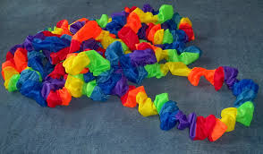
CONTENTS
These are listed alphabetically in three sections

SONGS FOR SCRUNCHIES
All over the place (warm-up)
Bim Bam boogie!
Calypso circle
Dancing in the ring
Pirates, pull and push
Roly poly pumpkin
Sing a Scrunchie
Spinning wheel
Up and down and inside out
Who’s in the castle?
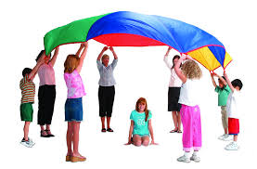

SONGS FOR LYCRA OR PARACHUTES
Bouncing beans
Bounce Bezulah
Hop little frog
Humpty Dumpty
Rock-a-bye Rosie
Roll-a-ball
Spaceship trip
Swim, swim, swim
Swing time

SONGS FOR SCRUNCHIES, LYCRA AND PARACHUTES
But what’s our next move? (warm-up)
Four round the ring
Jiggle about
Old MacScrunchie
Such a silly song!

SONGS FOR SCRUNCHIES

ALL OVER THE PLACE A Scrunchie activity
A Scrunchie warm-up
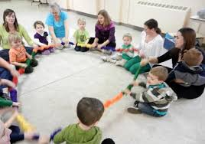
In the air; on the ground
Making ripples like the sea
Shake it up! Roll it round!
Hold it still as still can be!
Before you sing
Demonstrate the six Scrunchie actions, encouraging children to copy you:

- stretch up above your head
- reach down to the ground
- move alternate hands up and down
- shake randomly
- roll round
- keep absolutely still

Tackling the song
This song is extremely simple and works well as a warm-up. Encourage children to make the actions really clear, performing them together, tidily. This activity can be played sitting down
Developing the activity
Keeping to the rhyming pattern, substitute some new action ideas, for example:
Original line | One alternative | Another alternative
In the air | On your nose | On your chin
On the ground
Making ripples like the sea | Hopping like a little flea | Put the Scrunchie on your knee
Shake it up | Stretch it out | Bump your fists
Roll it round
Hold it still and still can be

BIM BAM BOOGIE!! A Scrunchie activity

Manage some quick-change moves

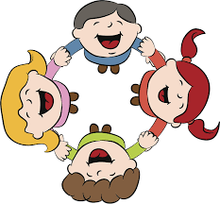
Bim, bam, boogie-woogie, bim, bam, boo!
Bim, bam, boogie-woogie, bim, bam, boo!
Bim, bam, bim, bam, boogie-woogie, boo!
Bim, bam, bim, bam, boogie-woogie, boo!

Before you sing
The activity is designed to work on coordination. Each of the four alliterative words: bim, bam, boogie-woogie, boo… is allocated a separate hand action. Practise these slowly, without the Scrunchie, placing hands on knees, initially, to learn the ‘moves’. Abandon any insistence on using left and right hands in order – this isn’t required and would detract from the fun.
bim one hand is lifted off the Scrunchie, returning…
bam … as the other hand repeats the action
boogie-woogie roll the Scrunchie round
boo bump fists together while holding on to the Scrunchie

Tackling the song

Sing slowly, without actions, until children are familiar with the tune and word order. When combining the song and actions for the first time, perform at a moderate pace and be prepared for muddles and giggles! Persevere! The performance will improve over time.

Developing the activity

When the actions are managed confidently you might consider speeding up the tempo for a really slick performance, perhaps in front of parents!

CALYPSO CIRCLE A Scrunchie activity
A dance song with a whiff of the Caribbean
Before you sing
Show footage of Caribbean dancers and musicians – you may be fortunate enough to have a steel band in your locality, so why not invite them to provide an impromptu concert and also accompany a performance of your ‘Calypso Circle’.
Tackling the song
This bouncy syncopated melody almost sings itself. Perform with improvised dance steps and jiggles to reflect the light-hearted nature of the song and remember to do the two stamps on every ‘we are’ – these words are supposed to be spoken, but singing them is perfectly acceptable!
Developing the song
Invite some keen performers to be the band, positioned in the centre, playing maracas and shakers to enhance the jaunty rhythm and the festive mood. You could make this a gathering game, beginning with a few participants round the Scrunchie and adding more players on each repeated verse.

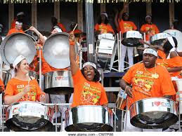

DANCING IN THE RING A Scrunchie activity

Friends in the ring - another Caribbean dance game

Now Maisie’s dancing in the ring (stamp, stamp)
Now Maisie’s dancing in the ring (stamp, stamp)
Now Maisie’s dancing in the ring, oh, Maisie
Ask a friend to come in (stamp, stamp)

Now two can do a dancing show (stamp, stamp)
Now two can do a dancing show (stamp, stamp)
Now two can do a dancing show, oh, Maisie
Now it’s time for you to go (stamp, stamp)

Before you sing

Talk with children about their experiences of dancing! Some may watch ‘Strictly’ with parents or older siblings; others may attend ballet, tap or other dance classes. Encourage them to demonstrate their favourite moments and ‘moves’.

Tackling the song

Explain that one dancer, performing in the centre, invites a friend to join in. The first dancer exits, leaving the second child to adopt the solo role. Make sure that ‘invitations’ are distributed fairly and are as inclusive as possible. Ask the Scrunchie ‘holders’ to perform invented dance steps to reflect the bouncy, calypso rhythm and stamp when indicated.

Developing the activity

Children positioned round the circle can be just as creative as the solo dancers – encourage players to let go of the Scrunchie with one hand in order to add energetic arm and turning movements to their performance.

PIRATES, PULL AND PUSH A Scrunchie activity
Sing to the familiar tune: Polly put the kettle on
A seafaring song to steer your crew to the treasure!
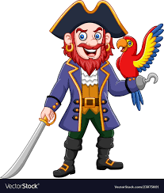
v1: Pirates, row across the sea
Pirates, row across the sea
Pirates, row across the sea
To search for gold!

v2: Push the oars and pull them back
Push the oars and pull them back
Push the oars and pull them back
We’ve found the gold!

Before you sing
Talk with children about pirates, sharing memories from familiar stories and films. Focus particularly on the subject of treasure, collecting the names of gems, jewellery and precious metals and showing images from books or online sources. Invite children to bring in their pirate toys, ships and dressing up articles for a display. Practise some rowing actions to a steady pulse (strong beat), leaning forwards with arms outstretched and then leaning back, to bring hands to waist level with elbows sticking out.
Tackling the song
This activity is performed sitting down. Ask a child to suggest the first item of treasure and sing about this in verse 1, rocking the Scrunchie from side to side like the waves of the sea. Don’t waste time and effort aiming for a uniform rocking direction, it won’t affect the game and the odd ‘collision’ will amuse the players! In verse 2, adopt the practised rowing action as dictated by the lyrics. Change the looked-for treasure in subsequent verses.

Developing the activity
Once the game is familiar provide different contexts for the pirates’ expedition, in order to extend the game and vary the vocabulary, for example, the pirates are planning a long voyage so sing about what would be needed… food, water, clothes, maps, rope…a parrot? Other less serious ideas might be for items needed for a surprise birthday for the captain: ‘Pirates, row across the shops,’ or a visit to the North Pole to visit Santa Claus: ‘Pirates, row across the ice,’ and let your collective imaginations run riot!

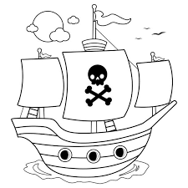
ROLY POLY PUMPKIN A Scrunchie activity
Enjoy a limelight moment, centre stage!

Roly poly, pumpkin, roly poly, pear
Ruby’s in the middle, sitting on a chair
Roly poly, pumpkin, roly poly, pie
Tom goes to the middle, Ruby says goodbye!

Before you sing
Players need to be aware of the key rhymes in this song: pear/chair and pie/ goodbye. Practise by playing a rhyming game using the images below e.g.: pear/chair; pie/goodbye; peach/beach; tea/key; cheese/bees and bread/head. Print the pictures as cards and invite children to find each rhyming pair.
Tackling the song
This activity can be performed sitting on the floor. Choose a child (Ruby) to sit on a chair in the middle of the Scrunchie ring. Explain that during the song, you will choose someone else to be centre stage and then bid ‘Ruby’ goodbye. Remind singers that this will require some good listening!
Developing the activity
Once the change-over pattern is established, invite the child in the centre to nominate their own successor and perhaps sing the last line independently!

 |  | 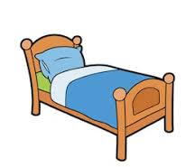 | 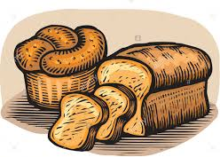 | 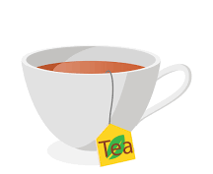
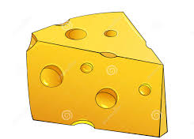 |  | 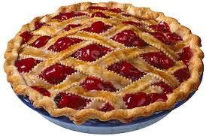 | 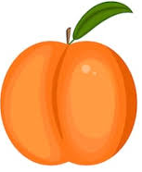 | 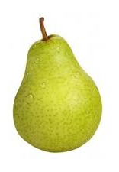 | 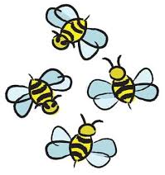
SING A SCRUNCHIE A Scrunchie activity
Sing about Scrunchie patterns

Who’s holding yellow? I‘m holding yellow
Who’s holding blue stripes? I‘m holding blue stripes
Who’s holding red spots? I‘m holding red spots
Let’s sing some more! Let’s sing some more!

Before you sing
Sit in a circle so that everyone is holding a section of the Scrunchie. Talk with children about the characters, objects and patterns seen on the different fabrics on your Scrunchie. Demonstrate how to play the game by modelling a sung question and answer about the fabric piece that you’re holding: e.g. ‘Who’s holding butterflies? I’m holding butterflies.’ Move to take up a different position round the circle and sing another question and answer that reflects the new design in your hands: ‘Who’s holding yellow stripes? I’m holding yellow stripes’. Repeat as necessary so that everyone understands the structure of the song.
Tackling the song
Begin with a general sung question to invite responses from all or most players e.g. ‘Who’s holding the Scrunchie? Who’s holding red?’ ‘Who’s holding an animal?… encouraging children to sing the echoed ‘Let’s sing some more!’ after each verse. If a response is missed, sing it yourself but insert the child’s name: ‘Shona’s holding butterflies?’
Developing the activity
Children will be in positioned differently round the Scrunchie every time you play this game, singing a range of contrasting responses. Once the pattern is firmly established, try other approaches, such as: ‘Who’s next to yellow?’ or ‘Who’s opposite pink flowers? Try more sophisticated questioning: ‘Who swims in the sea?’ or ‘Who has a tail?’ so that children ‘identify’ closely with their pattern or character. Encourage children to invent and sing questions, too!
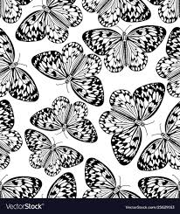 | 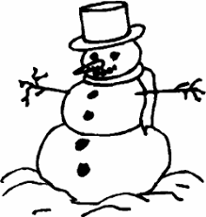 |  | 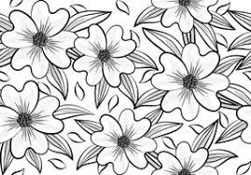
SPINNING WHEEL A Scrunchie activity
Spin and sing as you change direction
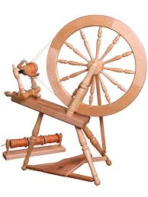
Turn the wheel, turn the wheel: keep the wheel spinning
Turn the wheel the other way, turning as we’re singing
Pass the thread; pass the thread, ‘til the work is done
Spin around, spin around and now the thread is spun.

Before you sing
This is a slightly more sophisticated activity and will require some practice. Show an image of a spinning wheel and explain its function. You might be lucky enough to have a parent or local crafts enthusiast who could offer a demonstration: you could also link the song to the story of ‘Sleeping Beauty’. ‘Pass the thread’ is performed by ‘feeding’ the Scrunchie through the players’ hands – this will require an agreed direction for passing and may need some rehearsal!

Tackling the song
Children hold the Scrunchie with their right hand only so that they face clockwise. Sing the first line, stepping on the strong beat: change direction for line 2. Stand still on line 3 as the Scrunchie is fed through players’ hands. The final line asks players to ‘spin round’. This is managed by letting go with one hand, turning to face away from the Scrunchie, then swapping hands to complete the spin, performed on the spot.
Developing the activity
Try skipping round instead of walking – this would give the activity a country dance flavour.

UP AND DOWN AND INSIDE OUT A Scrunchie activity
Can you follow these echo instructions?
Now hold the ring … and don’t let go…
Put it on your head… put it on your toe…
Can you lift it high? ... Can you get inside? …
Can make it stretch? … Can you make it wide? …

Before you sing

Echo songs are an excellent way to encourage focused listening. Practise the idea of copy singing by making up new lyrics to a well-known echo tune such as ‘Frère Jacques’, e.g.

Red and purple (echo)
Pink and blue (echo)
I can paint a picture (echo)
Just for you! (echo)

Tackling the song

Explain that every sung line is to be echoed. Sing the song slowly the first time so that everyone can hear and process the instructions. When you reach the line: ‘Can you make it stretch?’ model turning round to face outwards to ‘stretch’ and stepping away from the centre to ‘make it wide’.

Developing the activity

Change the lyrics to provide new instructions:
Now shake the ring, and roll it round
Put it on your knee, put it on the ground …..
Can you sit round the edge? Put it on your lap?
Can you lift it high? And drop it back!
WHO’S IN THE CASTLE? A Scrunchie activity
Sing about characters with time to rhyme!

In the castle, there’s a king
He’s a king who likes to sing
He’ll sing in the tower: la, la, la, la
He’ll sing in the dungeon: la, la, la
He’s a king who likes to sing

In the castle, there’s a ghost
He’s a ghost who moans the most
He’ll moan in the tower: ooh, ooh, ooh, ooh
He’ll moan in the dungeon: ooh, ooh, ooh
He’s a ghost who moans the most

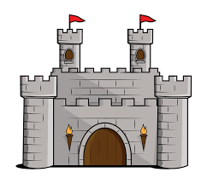
In the castle, there’s a queen, she’s a queen with boots of green
She’ll walk in the tower: stomp, stomp, stomp, stomp etc.

In the castle, there’s a witch, she’s a witch who likes to stitch
She’ll stitch in the tower: sew, sew, sew, sew etc.

In the castle, there’s a guard, he’s a guard who sweeps the yard
He’ll sweep in the tower: swish, swish, swish, swish etc.

In the castle, there’s a knight, he’s a knight who flies a kite
He’ll fly it in the tower: whoosh, whoosh, whoosh, whoosh etc.

You will need some props e.g. toy microphone, crown, white fabric, witch’s hat, broom, kite
Before you sing
Talk about characters that inhabit castles and revisit some favourite castle stories. The lyrics contain a strong rhyming element e.g. king/sing; queen/green so exploit this with an improvised rhyme game, for example: My cat wears a (hat); the dog chased a (frog); this bin is made of (tin). The musical focus is on pitch. Each character’s action occurs ‘in the tower’ (sung on high notes) and ‘in the dungeon’ (low notes).
Tackling the song
Children sit in a circle holding the Scrunchie, which represents the castle walls: choose a king to stand in the centre. When singing ‘…in the tower, ‘la, la, la, la’, children hold the Scrunchie high and bring it down to the floor for the ‘dungeon’ phrase. Encourage each character to invent some actions to enhance their role – see the list of suggested props!

Developing the activity

Support children in finding other single syllable characters and rhymed actions for new verses (don’t be too fussy about the castle theme): a fish who cooks a dish… a man who drives a van… a lord who waves a sword… an owl who gives a howl …

SONGS FOR LYCRA SHEETS AND PARACHUTES

BOUNCING BEANS A Lycra sheet or parachute activity
Counting with bouncy beanbags

You will need 5 or more beanbags
Before you sing
This counting game is very straightforward and needs no preparation.
Tackling the song
Place a beanbag on the Lycra sheet or parachute and ask one child to be responsible for the other four. When you’re ready to sing about two little beans, invite the beanbag holder to throw another one on to the sheet. If you’re lucky, you might end up with all five beanbags in place at the end of the game! As with ‘Humpy Dumpty’ (page 21), this song is ideal for small groups to explore independently, using half-size Lycra sheets or parachutes. Remember that old pillowcases, towels or tablecloths also work perfectly well with small numbers of players.

Developing the activity
Increase the number of beanbags to match the level of singers’ mathematical experience. Children could design and make their own 3D tissue or newspaper ‘beans’ with complete with faces. Try swapping ‘beans’ for other characters such as small soft toys or ‘bounceable’ items found in your setting – teddies, dolls or sponges.

BOUNCE BEZULAH A Lycra sheet or parachute activity
Where will Bezulah bounce to next time?

Bounce Bezulah up to town (x 3)
Bounce her up and bounce her down

Bounce Bezulah in the air …
Let the wind blow through in her hair

Bounce Bezulah to and fro ….
Round and round and round she’ll go

Bounce Bezulah in the sea….
She’ll come bouncing back to me

Bounce Bezulah to the moon….
She won’t get back very soon

Bounce Beluzah to the sky
Like a bird she’ll flap and fly

You will need a soft toy
Before you sing
Choose any soft toy and introduce him or her, as Bezulah. The song focuses on rhyming pairs so ask children to anticipate the rhymes in each verse before you play the game:
up to town/down… in the air/hair … to and fro/go … in the sea/me … to the moon/soon… to the sky/ fly
Tackling the song
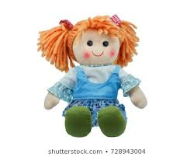
This is a fairly boisterous activity so expect Bezulah to bounce off the sheet at regular intervals! As you reach the last line of each verse, pause before the last word to see if children can supply the rhyme.
Developing the activity
Co-create new verses with accessible rhymes e.g.
Bounce Bezulah into school …
Bounce Bezulah on a train …
Bounce Bezulah down the slide …
Bounce Bezulah in a dream

HOP LITTLE FROG A Lycra sheet or parachute activity
Invent a hoppy, boppy frog song
Hop, hop, hop
Hop little frog
His name is *Fred
Hop, hop, hop!

Before you sing
Introduce the bean frog and ask some preliminary questions about his life to encourage imaginative answers: What’s his name? Where does he live? What does he eat? …. including nonsense questions, too: What’s his favourite television programme? What’s his brother’s name? Where did he go on holiday? This might be a useful exercise to elicit whole sentence responses, but if answers are short e.g. ‘fish and chips’ , expand these, modelling them as sentences in the song: What does he eat? He eats fish and chips!
Tackling the song
Expect the frog to be bounced off the sheet frequently – it all adds to the fun! Ask each new question before you sing a fresh ‘verse’, beginning with his name and incorporating the response into the third line. Construct the frog’s life story through further questioning and be prepared to fit the syllables of any long answers into the musical phrase as best you can: Where did he go on holiday? He went to Disneyland, Florida!
Developing the activity
Once the game is established, invite children to invent their own questions and nominate someone in the group to supply the answer. Once a ‘story’ has been created collectively, use it as a memory exercise and revisit the responses in order. These could be transferred to mark-making activities such as a sequenced cartoon strip or Z-book. To vary, play the game, using other ’cuddlies’ or soft toys.

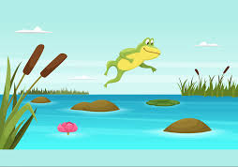 | 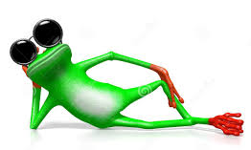 | 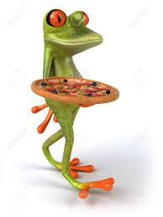 | 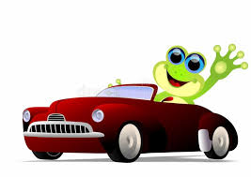

HUMPTY DUMPTY A Lycra sheet or parachute activity
A trampolining treat for Humpty!
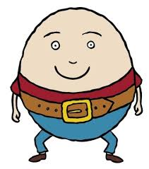

Humpty Dumpty, bump, bump, bump
Humpty Dumpty, jump, jump, jump
Humpty Dumpty, hop, hop, hop
Humpty Dumpty, run on the spot
Humpty Dumpty, bend your knees,
Humpty Dumpty, tiptoes, please
Humpty Dumpty, bounce to the sky
We’ll count to ten as you fly high!

Before you sing
If you don’t have a Humpty Dumpty toy in your setting, use any soft toy and change (repeat) the name accordingly: ‘Rabbit, Rabbit; Teddy, Teddy etc. The activity is very straightforward and needs no preparation other than clarifying the instruction ‘bump, bump, bump,’ which requests children to bump hands together as they hold the edge of Lycra or parachute, not their elbows or hips.
Tackling the song
Encourage everyone to sing the repeated name as you model and sing the actions. Children will learn the sequence very quickly and hopefully, anticipate the paired rhymes. You might not manage to keep Humpty on the sheet during the counting! This simple song is ideal for more intimate group play using half-size Lycra sheets or parachutes – old pillowcases or tablecloths also work perfectly well with small groups.
Developing the activity
Add a challenge by increasing the number of bounces to match the level of children’s mathematical experience.

ROCK-BYE ROSIE A Lycra sheet or parachute activity
Rock Rosie to sleep with a lullaby
Rosie Posie, sleepy head
Now it’s time to go to bed
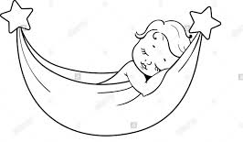
In the cradle you must go
We will rock you to and fro
Rosie Posie, say ‘Goodnight’
Off to sleep by starlight

You will need a doll or soft toy

Before you sing
Talk about the function of lullabies and why they are sung quietly: encourage children to make the rocking action used universally to lull babies to sleep, as you model the song. Explain that the Lycra sheet or parachute isn’t used for bouncing - in this song it acts like a hammock that sways the baby gently from side to side. The notes of the tune largely move stepwise, creating a calm and serene mood for inducing sleep.
Tackling the song
Place the doll or toy on the Lycra sheet or parachute and set up a smooth rocking action so that ‘Rosie’ stays in one position. Encourage children to sing quietly and sweetly – a fitting style for a lullaby in waltz time.
Developing the activity
Try humming instead singing the words - how quietly can your singers can perform this lullaby?

ROLL-A-BALL A Lycra sheet or parachute activity
Can you keep the ball rolling?

Rolling round the circle
Rolling round and round
One ball rolling
Keep it off the ground!

(Chanted)
Another ball, another ball!
Can we roll another ball?

Rolling round the circle
Rolling round and round
Two balls rolling
Keep them off the ground!

(Chanted)
Another ball, another ball!
Can we roll another ball?

You will need several small lightweight balls – the plastic variety with lots of holes would be ideal
Before you sing
Position children around the sheet - lift it a little way off the ground and practise rolling a ball round, gently. Explain that in this game, everyone works together, controlling the ball to prevent it from falling off! This will require concentration and a gentle up and down tipping action. If successful, players will be rewarded by trying with two balls … and so on. Remind children that there are sung and spoken parts.
Tackling the song
Ask children to practise rolling the ball while you model singing the song and chant - ask everyone to join in. What will your record be? Organise a suitably worthy reward if the group manage to keep five balls rolling on the sheet!
Developing the activity
Change the action to: ‘Bouncing round the circle…..’ will you manage to keep more than one ball bouncing?
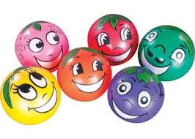
SPACESHIP TRIP A Lycra sheet or parachute activity
Countdown to the spaceship launch

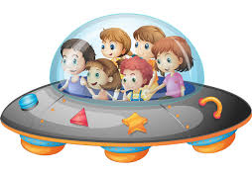
We’re guarding the spaceship
The astronauts are coming
It’s time for the launch
And the engine’s really humming!
Help us do the countdown
Then we’re off to space
(Spoken) 10, 9, 8
7, 6,
5, 4, 3,
2, 1 and ending with a zero
Whoosh!

Before you sing
Practise counting backwards from 10 to 0. The countdown in this activity is chanted rather than sung, but it has a very definite rhythm so check that children are saying the pattern accurately.
Tackling the song
Explain that the Lycra sheet or parachute is a spaceship – a large round one, not a rocket – and that after the count down, everyone launches the spaceship on ‘Whoosh!’ by flinging it up as high as possible. Decide whether singers should hold on to the sheet or release it entirely – letting go is much more fun!. This song can also be performed sitting down.
Developing the activity
Encourage children to change the ending of the line ‘Then we’re off to space!’ by substituting alternative destinations. These could be space-themed e.g. Mars, Venus the moon etc. or choose completely unlikely places …. the seaside, Centre Parcs, the Bat Cave!

SWIM, SWIM, SWIM! A Lycra sheet or parachute activity
Send a fish to explore new places!
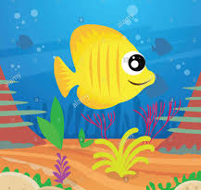
Swim, swim, swim
Swim, fishy, swim
Swim to the ocean
Swim, swim, swim

You will need a toy fish

Before you sing
Talk about life in a river or under the sea and perhaps share images to stimulate the discussion ( many children will have seen Disney’s ‘The Little Mermaid’). Introduce the fish and invite children to think of places that it might swim to – these can be ‘sensible’ e.g. a waterfall, a pond, a river, a beach…or let the fish’s journey reach more imaginative and unlikely places: the shops, a star, Disneyworld, a mountain etc.
Tackling the song
Children sit around the Lyra sheet or Parachute making small rippling movements, rather hefty bouncing actions so that the fish ‘swims’ quite gently. Decide on the first destination and sing this in line 3. Ask children for ideas for other journeys and incorporate these into the song.
Developing the activity
Encourage the child who supplies the destination to sing the line as a solo. Adapt the song for other toy ‘creatures’ and change the verb accordingly, for example:

Trot, trot, trot
Trot, pony, trot
Trot to the meadow
Trot, trot, trot

Roll, roll, roll
Roll, hedgehog, roll
Roll to the forest
Roll, roll, roll

Slide, slide, slide
Slide, snake, slide
Slide through the jungle
Slide, slide, slide

SWING TIME A Lycra sheet or parachute activity
Singers fly under a swinging sky
Swing, swing, Rajesh,
Are you going under the sky?’
(soloist) Yes, I am, yes, I am
Swing, high and watch him (her) fly!

Before you sing
At the end of this song, the Lycra sheet or parachute is swung high while a nominated child travels underneath to take up a new position on the opposite side of the circle. Practise the activity, singing the song without the sheet, initially, so that children really understand how the game works.
Tackling the activity
Explain that the sheet represents the sky. Make a decision about the travelling style; running may be inappropriate and there will be plenty of time for more sedate moves! When trying out the song for the first time, select a child who you know will manage the travelling and solo singing role – this initial modelling will support less confident participants when they take their turn. Announce the chosen child’s name before you begin each verse, so that everyone sings the opening line. Sing slowly and enjoy the gently swaying rhythm as you move the sheet from side to side.
Developing the activity
Once the game is familiar, choose a confident ’leader’ to sing the ‘flying’ invitation each time. Encourage children to invent different ways of travelling across the circle, for example: skipping, swaying, jumping, hopping, tiptoeing or dancing.

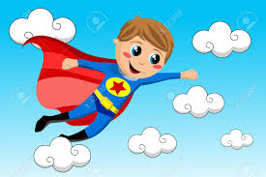
OLD MACSCRUNCHIE A Scrunchie activity
Sing to the familiar tune: Old MacDonald had a farm
Move to the beat as you travel round
Old MacScrunchie likes to walk
All around the ring
Old MacScrunchie likes to walk
And he likes to sing!
*With one step here and another step there
Feel the beat and keep the pattern going!
*Old MacScrunchie likes to walk
All around the ring

Old MacScrunchie likes to jump
All around the ring
Old MacScrunchie likes to jump
And he likes to sing!
With one jump here and another jump there
Feel the beat and keep the pattern going!
Old MacScrunchie likes to jump
All around the ring

Before you sing
Collect vocabulary for different ways of travelling on foot e.g. hop, skip, run, slide, leap, march, strut, creep, jog, trot … encouraging children to demonstrate the actions, too. Use a tambourine to provide a steady beat, or simply clap, asking children to perform their travelling actions to that beat.

Tackling the song
Hold the Scrunchie, Lycra or parachute with RIGHT hands only to establish a unified direction for moving round the circle - this will be easier than side-to-side stepping, Begin by singing about walking as the first mode of travel and model your steps to fall on the strong beat – these are indicated by the underlined syllables in lines 5 & 6. Ask children to choose alternate ways of travelling for new verses.
NB: For some travelling moves i.e. march, creep, you will need to revert to: ’one step … another step…’ in line 5 to make sense of the travelling action.

Developing the activity
Once the game is familiar; experiment with changes of direction. This could be for each new verse, or, for a real challenge, change direction on every other line (asterisked)
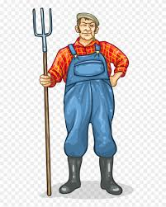

SONGS FOR SCRUNCHIE, LYCRA OR PARACHUTE

BUT WHAT’S OUR NEXT MOVE?
A warm-up for Scrunchie, Lycra sheet or parachute
Make up new circle moves

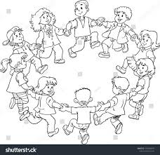

Walking round,
That’s what we do
We could try
Something that’s new
Can we make our feet
Move another way?
How shall we travel today?

Before you sing
Collect words for different ways of travelling on foot e.g. hop, skip, run, slide, leap, march, strut, tiptoe, creep, jog, trot, star jump … encouraging children to demonstrate the actions.

Tackling the song
This is essentially a warm-up activity. Choose a consistent direction for travelling and sing the first verse as you walk round, stepping side-to-side, then ask for new ideas for subsequent verses. Encourage each child who suggests the new move to sing the opening line: ‘Walking round; tiptoe round, star; jumping round’ … as a solo.

Developing the activity
Try making all actions fit to the pulse (strong beat) – the underlined syllables will help.

FOUR ROUND THE RING An activity for a Scrunchie, Lycra sheet or parachute
Invite singers to join the game

Four round the ring, yes, four round the ring
Four round the ring and four will do
But here’s an idea I’d like you to hear?
Let’s bring in someone new!

Five in the ring …

Before you sing
This simple activity needs little preparation: children only have to add one for each new verse. It may be worth reinforcing the idea of fairness when inviting a new player - to resist always asking a best friend.
Tackling the activity
If you have a large number of children, begin with a higher number of players, to avoid too much waiting time. Ask the ‘beginner’ group to position themselves evenly round the circle: the rest sit ready to be summoned to the game. Establish a rule that the last child to join the game nominates the next player – this will allow the game progress more smoothly.
Developing the activity
Extend the game by inviting the new player not by name, but by a simple description, for example: I invite someone who is wearing red trianers …. a pink hairband…. a green jumper…who’s sitting next to Lily… You could speed up the action by inviting TWO children each time.

JIGGLE ABOUT An activity for a Scrunchie, Lycra sheet or parachute
Sing to the familiar tune: Knees up, Mother Brown
Dance and jig to faraway places

Dance and jig about, dancing to Beijing
Dance and jiggle, dance and jiggle
Jiggle as you sing!

Dance and jig about, dancing to Algiers
Dance and jiggle, dance and jiggle
Jiggle both your ears!

Dance and jig about, dancing to Toulouse
Dance and jiggle, dance and jiggle
Jiggle in your shoes!

Dance and jig about, dancing to Montrose
Dance and jiggle, dance and jiggle
Jiggle on your toes!

Dance and jig about, dancing to Belize
Dance and jiggle, dance and jiggle
Jiggle both your knees!

Dance and jig about, dancing to Brazil
Dance and jiggle, dance and jiggle
Now we all keep still!

Before you sing
Another song with a strong rhyming focus, but not the geographical one, which might be assumed from the place names in the lyrics! Prepare for the rhyming pattern, by asking children to recall rhymes for the final word of each verse: e.g. sing (swing, ring, thing, fling); shoes (blues, choose, lose) and practise the jiggling actions found in the final lines.
Tackling the song
Remind children that the song needs energetic dancing and jiggling. Model the first verse so that singers have an opportunity to make the rhyme connection, then try all the verses.
Developing the song
The familiar tune is very jaunty! Encourage a small group of children to select percussion instruments and improvise an accompaniement to the dance.

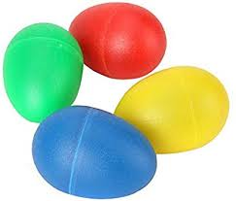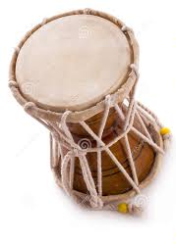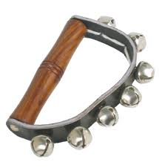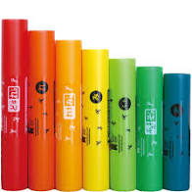

SUCH A SILLY SONG! An activity for a Scrunchie, Lycra sheet or parachute
Sing about six sillies with colourful names

Bertie Black, Bertie Black
He put snowballs in a sack.
That’s not right, that’s all wrong
He’d (she’d) better off singing this song!
With an up, up, up, and a down, down, down
Do a very silly dance like a circus clown
With a shake, shake, shake
Stay awake, wake, wake
And join our very silly song

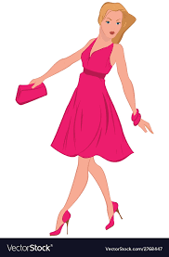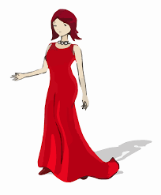

v2: Rita Red, Rita Red
She grew bananas in her bed etc.

v3: Poppy Pink, Poppy Pink
She kept sausages in her sink etc.

v4: Billy Blue, Billy Blue
He wore glasses made of glue etc.

v5: Gary Grey, Gary Grey
He made carpets out of clay etc.

v6: Brenda Brown, Brenda Brown
She rode tortoises into town etc.

Before you sing
The lyrics focus on alliteration and predictable rhyming patterns. When you introduce each ‘colourful’ character and their silly action, some children may be able to guess the alliterative surname and/or the rhyming item from the context, depending on their linguistic skills and experience. Play alliterative and rhyming games to warm-up and to encourage participation from everyone.
Tackling the song
The verses are quite long but they all repeat the same words apart from the opening lines. Lift the Scrunchie or sheet up and down, as indicated, with appropriate ‘dance’ and ‘shake’ actions.
Developing the activity
Invent more colour-themed alliterative characters e.g. Georgie Green, Winnie White, Michael Mauve etc. and make up silly stories to sing about, but don’t be overly concerned about continuing the alliteration.
TO MAKE A SCRUNCHIE WITH CONTRASTING FABRIC DESIGNS
A Scrunchie is essentially a circle of strong elastic encased in a tube of ruched fabric. As mentioned at the beginning of the book, commercial Scrunchies are often made of one single fabric or sometimes of a few plain colours. A ‘home-made’ one has the advantage of being able to including several different fabric designs – a feature which can be exploited in singing games (see ‘Sing a Scrunchie’).
SCRUNCHIE SIZES FOR DIFFERENT GROUPS OF CHILDREN
A 10-metre Scrunchie will accommodate approximately15 EYFS children: ‘10 metres’ refers to the fully stretched Scrunchie circle circumference. A 15-metre Scrunchie accommodates 30 children; a 5-metre Scrunchie would suit a smaller group.
MAKING A SCRUNCHIE USING AN EXISTING STOCK OF FABRIC
If you are a fabric hoarder with plenty in stock, you can construct a Scrunchie from remnants and bits and pieces. But if you’re starting from scratch, more guidance is given in the paragraph MAKING A SCRUNCHIE FROM SCRATCH.

FOR A 10-METRE SCRUNCHIE YOU WILL NEED:

15 strips of contrasting polycotton fabric x 75 cm long and 22.5 cm wide
5 metres of strong elastic of 1.5 inches /3 cm width
Thread and pins
Sewing machine
Iron/ironing board
1 x large safety pin
1 x VERY LARGE safety pin (a kilt pin is idea)

MEASUREMENTS FOR OTHER SIZES:
For a 15-metre Scrunchie
20 strips x 75 cm long/ 22.5 cm wide + 7.5 metres of strong elastic of 1.5 inches /3 cm width

For a 5-metre Scrunchie
8 strips x 75 cm long/ 22.5 cm wide + 2.5 metres of strong elastic of 1.5 inches /3 cm width

MAKING A SCRUNCHIE FROM SCRATCH
BUYING FABRIC
Polycotton fabric is robust, washable and cheap – it is available online and possibly at your local market, if you’re lucky enough to have one with a fabric stall. Prices vary, but you should be able to buy it for less than £3 per metre. Polycotton is approximately 112 cm wide, which can be cut into 5 strips of 22.5 cm – the ideal width for making the Scrunchie ‘tube’. 1.5 metre of Polycotton, cut in half widthways will give 10 strips of 75 cm length.

GUIDANCE ON HOW MUCH POLYCOTTON TO BUY
If you want a Scrunchie made up of entirely different designs – you will need to buy a greater number of fabric lengths.

ONE EXAMPLE: Many other variations are possible
From 1.5 metres x 10 contrasting fabrics (100 strips) you could make 7 Scrunchies:

2 x 15-metre Scrunchie (20 strips, with each design repeated twice) Total 44 fabric strips
2 x 10-metre Scrunchie (15 strips, with 5 designs repeated twice) Total 30 fabric strips
3 x 5-metre Scrunchie (8 strips each, with no repeated designs) Total 24 fabric strips

ANOTHER EXAMPLE:
From 1.5 metres x 5 contrasting fabrics (50 strips) you could make 3 Scrunchies:

1 x 15-metre Scrunchie (20 strips with each design repeated 4 times) Total 20 strips
2 x 10-metre Scrunchie (15 strips with each design repeated 3 times) Total 30 strips

INSTRUCTIONS FOR MAKING A SCRUNCHIE
- Fold over 1.5 cm on the long sides of each 75 cm fabric strip and iron for a crisp edge.
- Arrange your fabric strips in a pleasing sequence and pin the short ends together (right sides facing), making one very long strip.
- Machine stitch all these short seams, opening out the ironed folds as you stitch.
- Join the ‘beginning’ and ‘end’ pieces to complete the circle, check that there are no twists.
- Pin the long folded edges together to make a tube (right sides outside), keeping the short seam edges inside the tube all facing in one direction - this makes it easier to pass the kilt pin round as you thread the elastic!
- Machine all round, leaving an opening of 12 cm for inserting the elastic.
- Use a safety pin to secure one end of the elastic to the inside of the fabric tube, near the opening. Attach the kilt pin to the other end of the elastic and pass it through the tube, dragging the elastic through behind, until you reach the opening again.
- Unpin the two elastic ends, lift them well away from the fabric tube, overlap them by 3 cm, and sew together, machining across several times with a zigzag stitch, to make a really strong join.
- Machine across the opening ‘gap’, right sides together, to close the tube completely.
© Sue Nicholls

